Eagle Harbour Yacht Club

Eagle Harbour Club Invitational Race
Sunday, April 13th, 2014, at 10:30 a.m.
Notice of Race and Sailing Instructions
- Rules, Eligibility, Scoring and Registration
The race will be governed by the rules defined in the Racing Rules of Sailing (RRS). It will be scored on the PHRF time on time basis. Skippers shall provide a current copy of their boat's PHRF rating issued by Sailing BC. Should any vessel not have a current PHRF rating, a provisional handicap will be assigned before the start of the race.
The entry form is attached and is also available from our fleet captain by email at: fleetcaptain@ehyc.org.
Participants may register at the EHYC clubhouse at any time up to the start of the race or they may email the completed form to kbrownlow@gmail.com by Saturday, April 12th.
- Entry Fee
The entry fee for those who have not already registered with the Bowen Island Yacht Club Devil’s Tankard Series is $15, which members of EHYC and WVYC may charge to their club accounts if they so wish. The entry fee for those registered in the Devil’s Tankard Series has already paid. Please note that the entry fee does not include food or beverages at the barbeque after the race - see paragraph 15 below.
- Divisions
There will be two divisions: Division A for boats with a PHRF of BC handicap equal to or less than 150 and Division B for boats with a PHRF of BC handicap equal to or greater than 151.
- Skippers' Meeting
A non-mandatory skippers' meeting will be held at 9:00 a.m. on the day of the race at the EHYC clubhouse.
- VHF
The Race Committee will communicate via VHF channel 73 where necessary.

- "Class flag" for the purposes of the starting sequence
The No.1 pennant will be used as the class flag for the purposes of the starting sequence. Boats will not be expected to display a class or division pennant.
- Start
The 5 minute start sequence as described in Rule 26 of the RRS will commence with a warning signal at 10:25 a.m. Divisions A and B will start together.

The start sequence will therefore be as follows:
Minutes | Visual signal | Sound | Meaning
to start
5 | No.1 pennant | 1 | WARNING
4 | Flag P | 1 | PREPARATORY
1 | Flag P removed | 1 long | ONE MINUTE
0 | No. I pennant removed | 1 | START
See paragraph 12 below for the visual signals that will be used.
The Race Committee will attempt to call boats that are over the line early on VHF channel 73. Nevertheless, it is the responsibility of the skipper of a boat over early to return and start correctly if a recall is signaled by flag, whether or not the Race Committee issues an alert via VHF.
- Postponement
The Race Committee may, at its discretion, postpone the start of the race.
- Course
The start line will be located off Eagle Island outside Eagle Harbour, between a committee boat and an anchored buoy. The course marks will be Passage Island, Bird Islet and the start pin. The direction of the course will depend on wind direction and will be determined by the Race Committee before the start of the race.
A clockwise course will keep all marks to starboard, and a counterclockwise course will keep all marks to port. The Race Committee boat at the start line will display a green flag to indicate a clockwise course and a red flag to indicate a counterclockwise course.
The race will make two circuits of the course.
- Finish
The finish line will be between a committee boat and an anchored buoy in the same area as the start. The Race Committee may, however, shorten the course and set the finish at any of the turning marks in order to keep the race within the time limit. If the course is shortened it will be shortened the same for all divisions.

- Time Limitation
There will be a limit of 3 hours for the first boat in each division to finish the course. In order to qualify as a finisher, all remaining boats must finish within 60 minutes of the first boat in their division crossing the line.
- These are the visual signals that will be used:

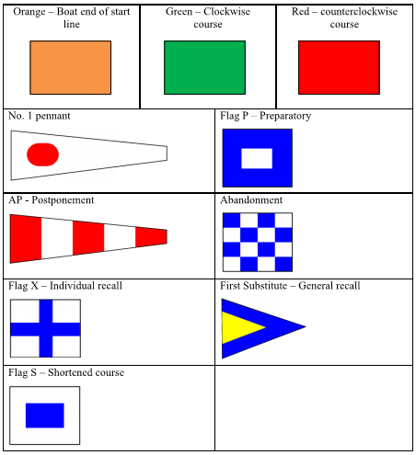

- Disclaimer of Liability
The decision to race rests with the skipper. Competitors take part in this race entirely at their own risk. EHYC and the Race Committee will accept no liability for material damage or personal injury or death sustained in conjunction with, prior to, during or after the race.

- Insurance
Each participating boat shall carry valid third party liability insurance with a minimum coverage of $1,000,000. Proof of insurance shall be carried on the boat.
- Post-race barbeque
EHYC will host a post-race barbeque on the EHYC clubhouse patio. All entrants and interested parties are welcome and encouraged to attend. In contrast to earlier years, the entry fee for the race does not include the cost of the skipper's refreshments. The cost of food and beverages for all participants will therefore be $3 for a burger and $3 for a beer.
- Further information
For further information, please contact Kent Brownlow at kentbrownlow@gmail.com.

Eagle Harbour Yacht Club
Club Invitational Race
Sunday April 13, 2014
Entry Form

Owner/Skipper |  | Boat Name
Address |  | Sail No.
 |  | Yacht Builder
 |  | Model
 |  | Length
Phone # Home |  | Yacht Club
Phone # Work |  | PHRF Rating
e-mail |  |  | Tick box if provisional handicap
 |  |  | required
Please tick as appropriate: |  | Division |  | A: PHRF≤150 | B: PHRF ≥151
Fee enclosed | Charge to my | (please tick
 | EHYC/WVYC account | relevant box)
 | No.:
This entry covers the EHYC Club Invitational Race scheduled to be held on the date and at the time stated above. The Notice of Race and Sailing Instructions are available at the EHYC clubhouse and are subject to change up to the morning of the race.
Release: I have read the rules and regulations of this event and am bound by them and by the Racing Rules of Sailing as defined by the ISAF and the CYA. I acknowledge that the decision to race and to ensure the seaworthiness of the boat lies entirely with the owner/skipper and that participation in this event is entirely at the owner's/skipper's risk. The owner/skipper will not hold EHYC, the race organizers and committee or any others involved in running this event responsible for any liabilities, actions, damage, claims or demands that may arise from participation in this event.
I also warrant that the vessel is seaworthy and at the time of the race carries appropriate liability insurance coverage of not less than $1,000,000 and that the policy covers the activity of sailboat racing and any other activities involved in participation in this event.

Signed: _

Date:

