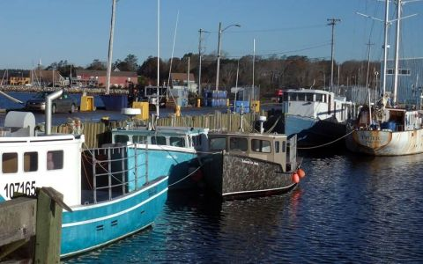
(Lobster boats in Shelburne, Nova Scotia)
Eagle Harbour Yacht Club
10th Annual Lobster Boil

Friday, June 12, 2015
Refreshments – 6:30 PM
Dinner – 7:30 PM

Cost - $40/person
Extra Lobster $15

To register for the event
contact Susan Larlee at
slarlee@shaw.ca

Only 100 seats available
Register before June 09th

