Menu |  | - October 25, 2014  - Commodore’s Dinner
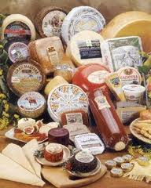  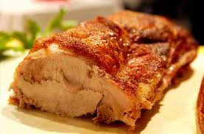  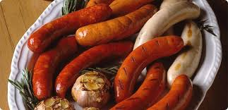  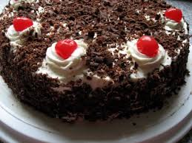 |  | Appetizers  Pretzels, Bread, German cheeses and sausages  Roast Pork with Fennel and Apple Sauce  Roast Potatoes  Sauerkraut and Red Cabbage  German Sausages  [Menu item description.]  Black Forest Cake  Apple Strudel  Assortment of German Beers and Wine  Germa

